City of Ellisville Park Board
Regular Meeting – July 22, 2024 ● 7:00 p.m.
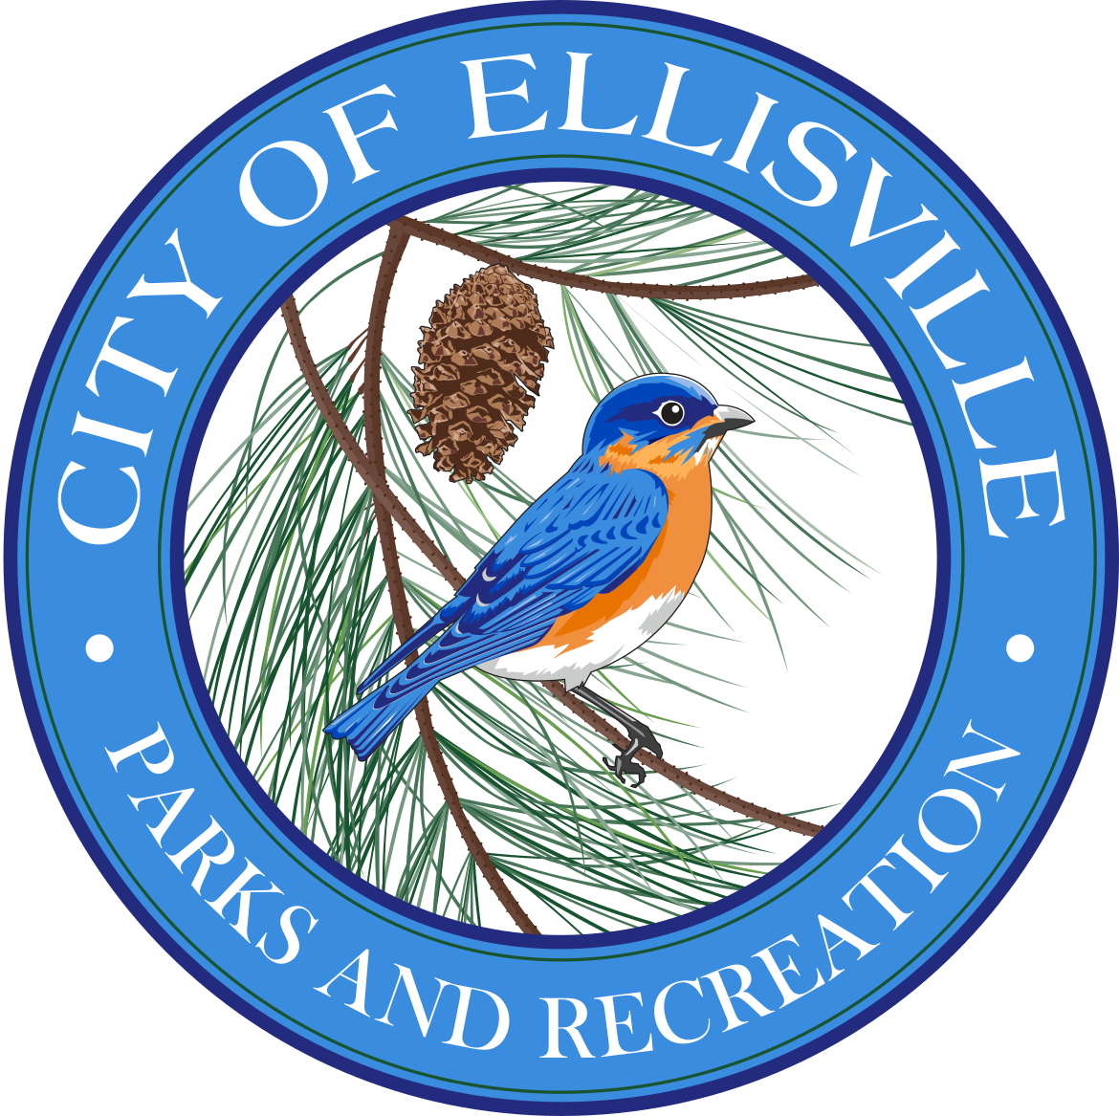

- Call to Order

P. Councilor  T. Elwell  P. Gay  E. Laboube  J. Mueller  J. Powell | G. Sackett  C. Slota  G. Zuzack  S. Grobelny  A. Peper
- Approval of Agenda

- Approval of Minutes
- April 22, 2024

- Public Comment

- Introduction of new Park Board members

- Director’s Report
- Memberships
- Recreation Programs and Events
- Grants
- Misc: AED, Meadowlark, Polling Place

- Old Business
- Mockingbird Park update
- Owl Hollow

- New Business
- Pool

- Public Comments

- Adjournment – Next Meeting – Monday, October 21, 2024

PARK BOARD

Greg Zuzack
Chair
Cindy Slota
Vice Chair
P. Councilor
T. Elwell
Peggy Gay
Emily Laboube
John Mueller
John Powell
George Sackett

PARKS & RECREATION DEPARTMENT

Sally Grobelny
Director
Meghan Fadler
Recreation Coordinator
Amber Peper
Recreation Specialist

The City of Ellisville is currently working to comply with the Americans with Disabilities Act mandates. Persons requiring auxiliary aids to attend a meeting should contact our office at least 72 hours in advance and communicate their needs. Parks Office: (636) 227-7508

225 Kiefer Creek Road, Ellisville, MO 63021 (636)227-7508 Fax: (636)230-2937
www.ellisville.mo.us

